1. Etp downloaded-lib and ext folders from TAFJ home moved to D:\Temenos\jboss\modules\com\temenos\tafj\main
2. Jboss started.

Xml file generated:

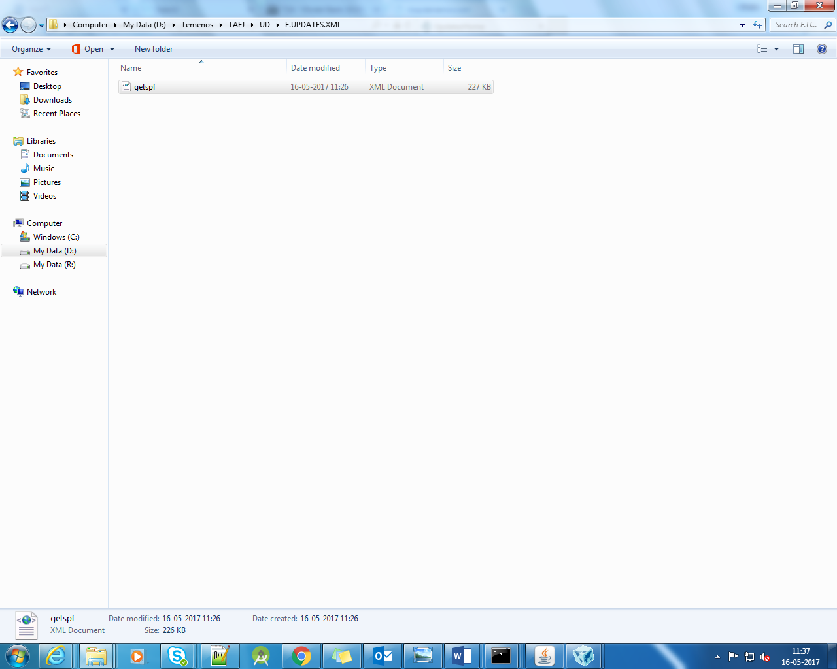

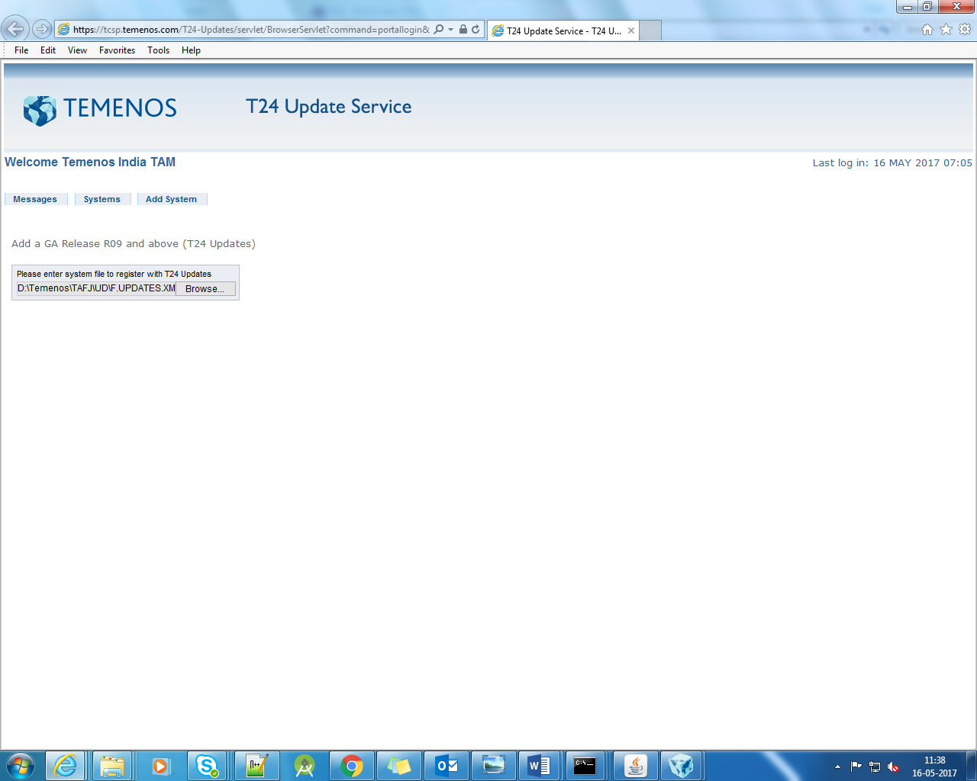

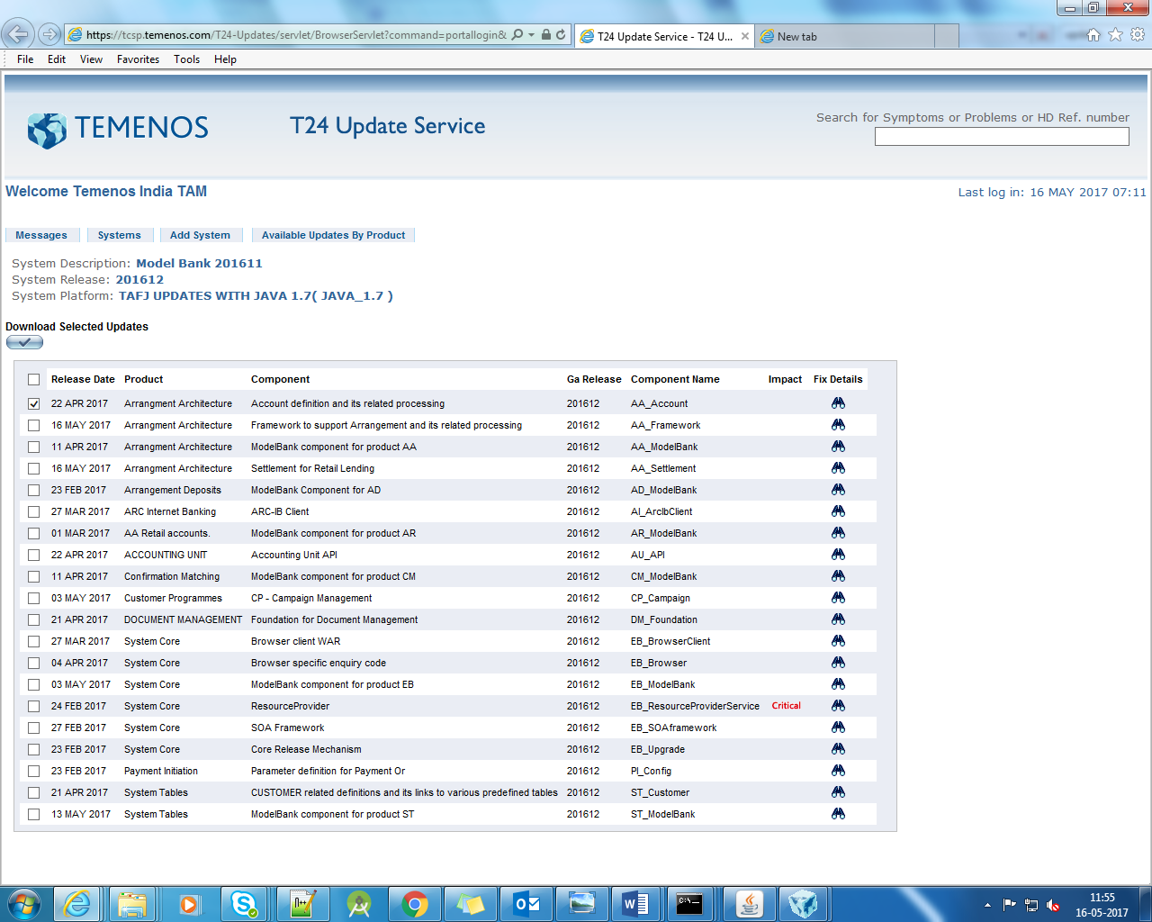

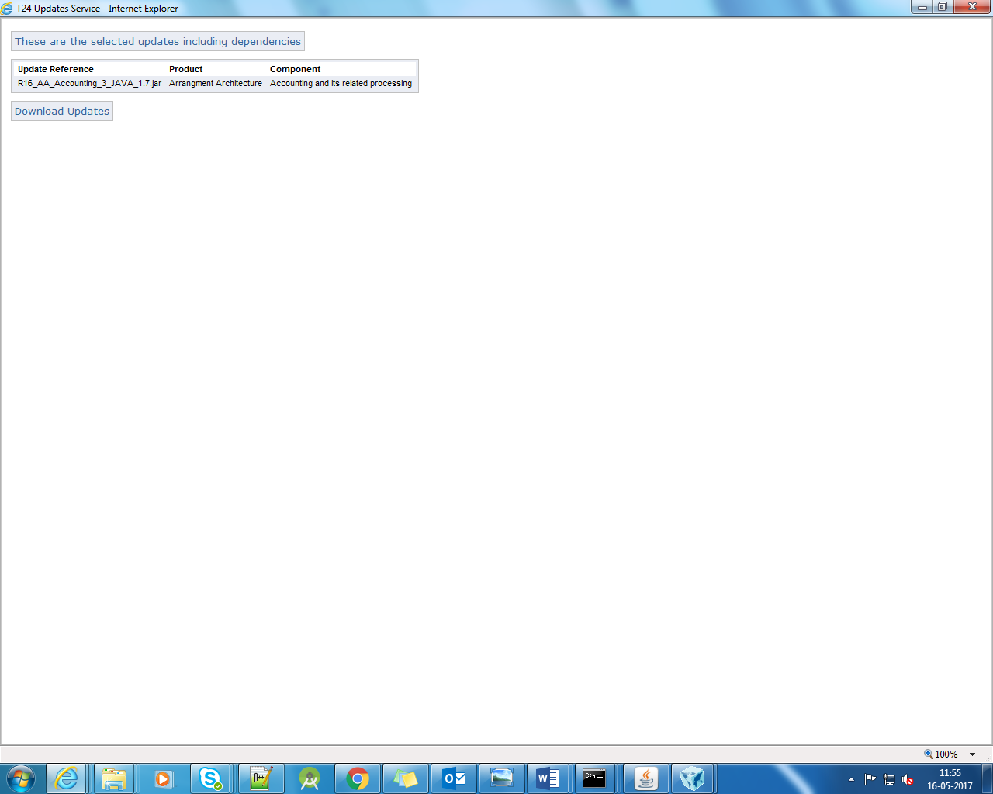

updater.bat

GOT AN ERROR INITIALLY

RECTIFIED RUNNING IT THROUGH A BAT COMMAND

PATH RELATED ISSUE PROBABLY

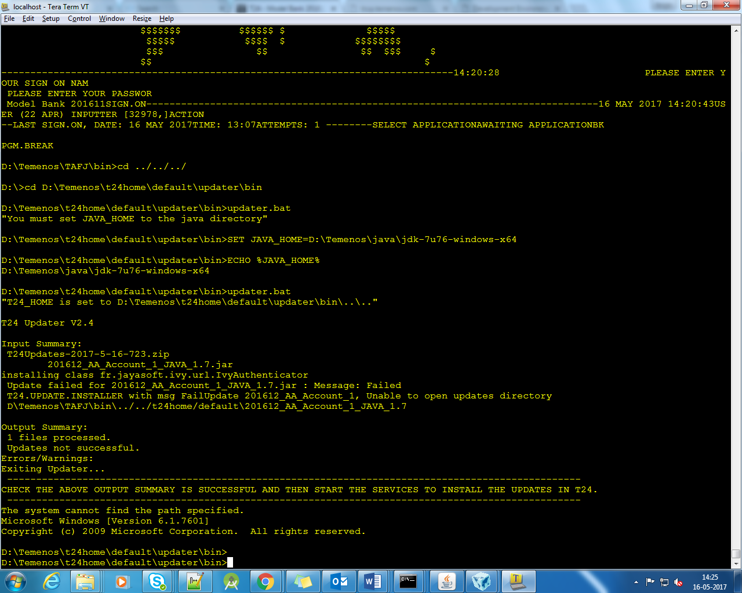

WITH ERROR

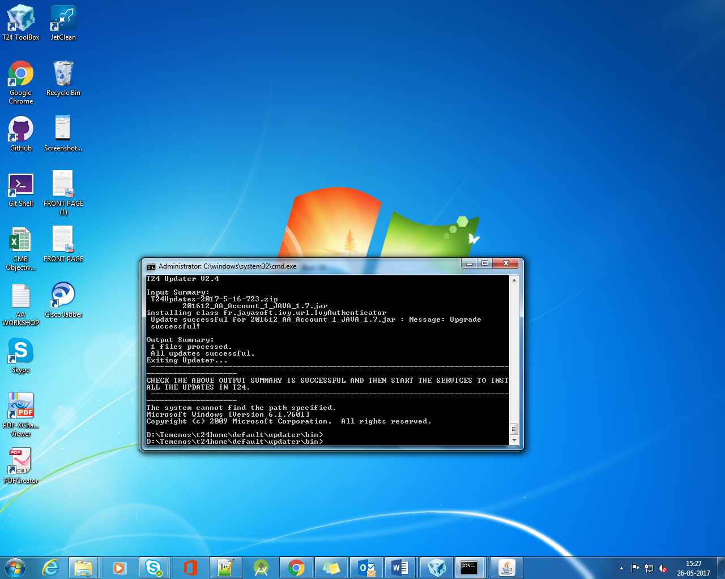

WITHOUT ERROR

After running the bat file run the service BNK/T24.UPDATE

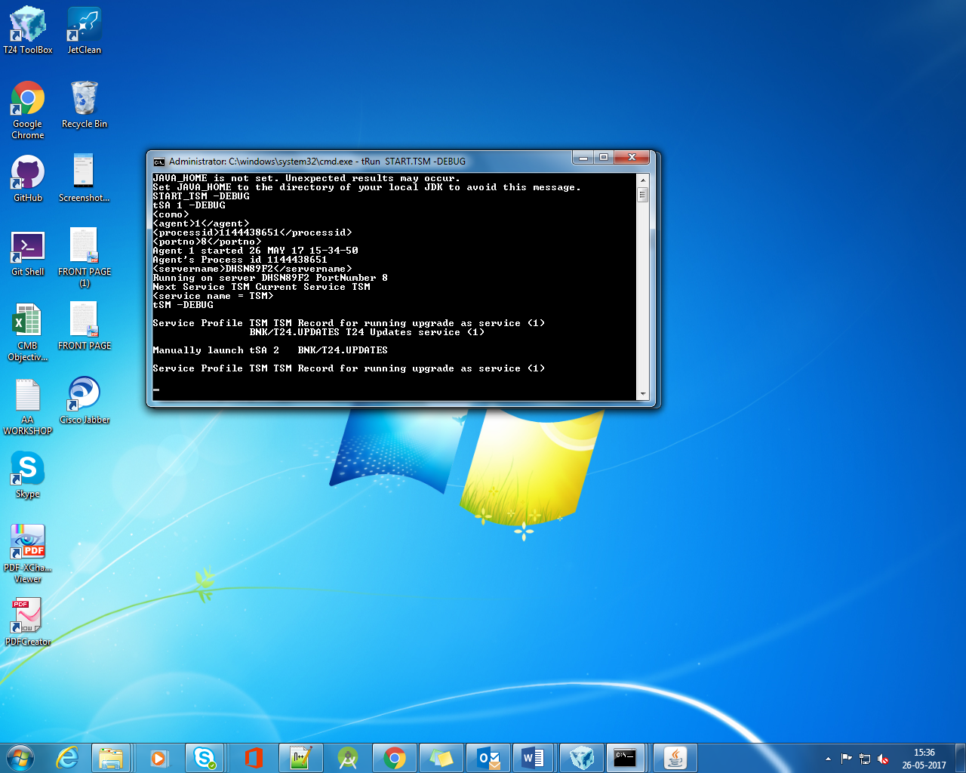

START THE AGENT

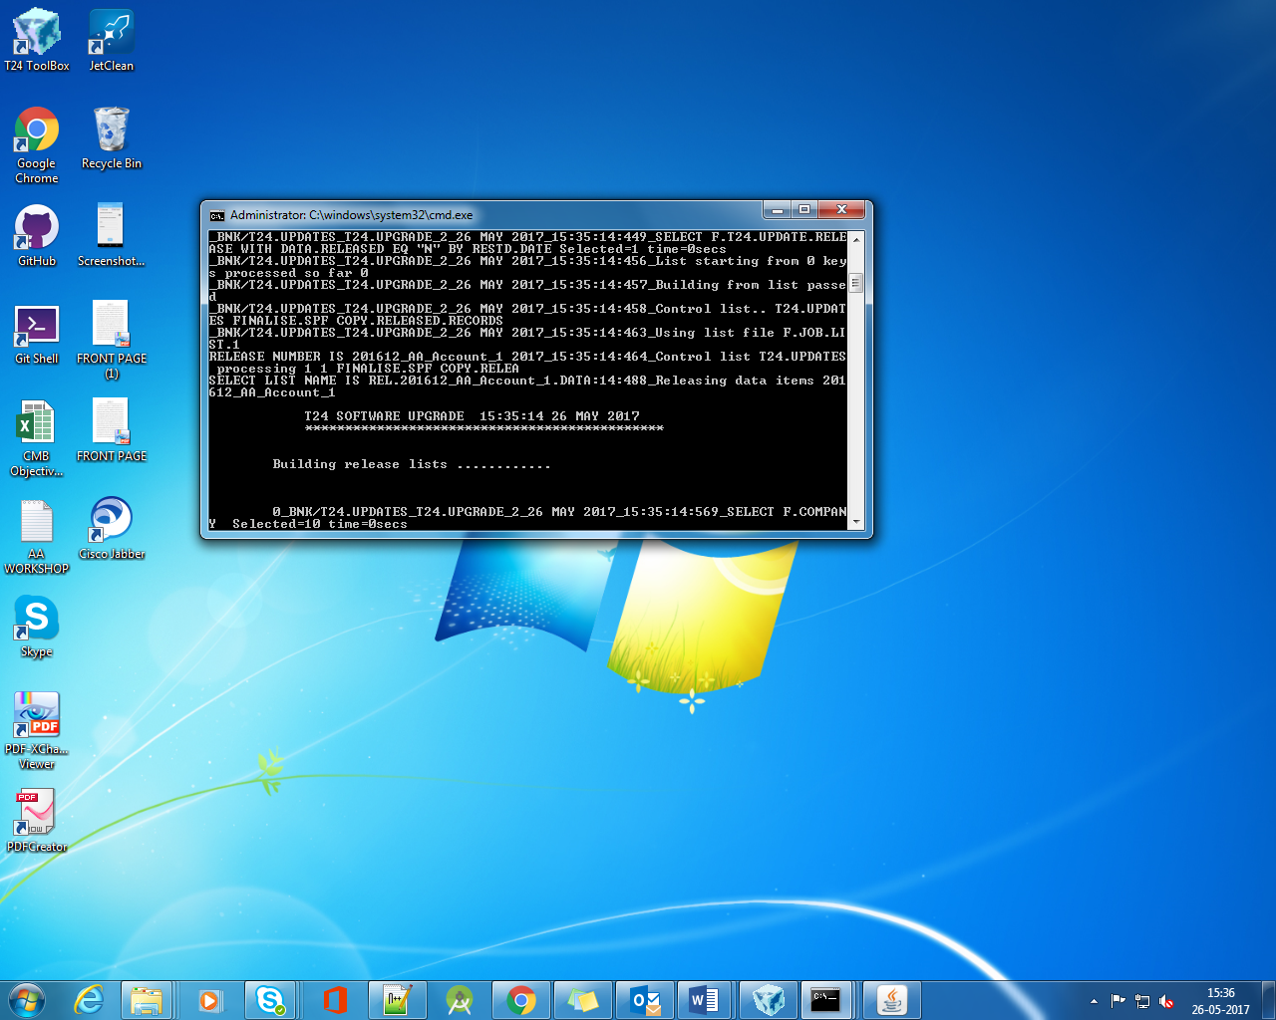

After this step check SPF for updates

